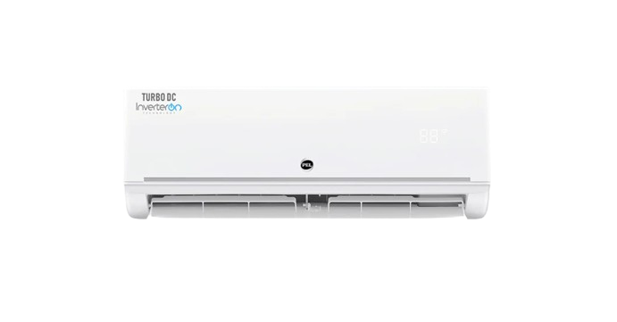
PEL InverterOn AERO Extend — Detailed Product Document

Overview
The PEL InverterOn AERO Extend is a Heat & Cool inverter split air conditioner designed for high energy-efficiency and performance. It runs on Pakistan’s 220–240V 50Hz system and uses R32 eco-friendly refrigerant.

Available Capacities
• 1 Ton (12k)
• 1.5 Ton (18k)

Key Features
• Inverter Technology — variable speed compressor
• Heat & Cool Function
• R32 Refrigerant — eco-friendly
• Low noise indoor unit
• High airflow & stable outdoor unit

Technical Specifications — 1 Ton (12k)
Cooling Capacity (rated): 1140 W (Range: 270 ~ 1260 W)
Cooling Current (Range): 1.85 ~ 5.52 A
Rated Current: 9.0 A
Heating Capacity (rated): 980 W (Range: 450 ~ 1100 W)
Rated Power Input: 1800 W
EER: 3.21
Airflow (Indoor): 600 m³/h
Noise (Outdoor): 55 dB(A)
Indoor Unit Weight: 8 kg
Outdoor Unit Weight: 23.1 kg
Indoor Dimensions: 805 × 194 × 285 mm
Outdoor Dimensions: 765 × 303 × 555 mm

Technical Specifications — 1.5 Ton (18k)
Cooling Capacity (rated): 1640 W (Range: 550 ~ 1960 W)
Cooling Current (Range): 3.80 ~ 8.60 A
Rated Current: 14 A
Heating Capacity (rated): 1500 W (Range: 500 ~ 1585 W)
Rated Power Input: 2650 W
EER: 3.22
Airflow (Indoor): 840 m³/h
Noise (Outdoor): 56 dB(A)
Indoor Unit Weight: 10 kg
Outdoor Unit Weight: 27.4 kg
Indoor Dimensions: 957 × 213 × 302 mm
Outdoor Dimensions: 765 × 303 × 555 mm

Package Contents
• Indoor Unit
• Outdoor Unit
• Remote Control
• User Manual
• Installation Kit

Warranty
• Compressor: 10 Years
• PCB: 5 Years
• Parts: 1 Year

Safety & Installation Notes
• Proper wiring according to rated current
• Stable mounting for indoor & outdoor units
• Maintain airflow clearance
• Installation should be done by certified technicians

